PIZZA SALES SQL QUERIES

1.KPI

1. Total Revenue:

select SUM(total_price) AS Total_Revenue from pizza_sales

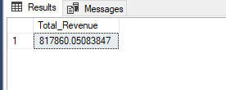

1. Average Order Value

SELECT SUM(total_price) / COUNT(DISTINCT order_id) as Avg_Order_Value

from pizza_sales

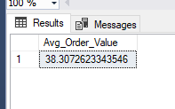

1. Total Pizza Sold

SELECT SUM(quantity) as Total_Pizza_Sold

from pizza_sales

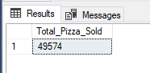

1. Total Orders

SELECT COUNT(DISTINCT order_id) as Total_Orders

from pizza_sales

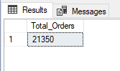

1. Average Pizza Per Order

SELECT CAST(CAST(SUM(quantity) AS DECIMAL(10,2)) / CAST(COUNT(DISTINCT order_id) AS DECIMAL(10,2)) AS DECIMAL(10,2))

AS Average_Pizza_Per_Order

from pizza_sales

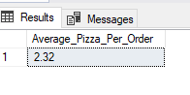

1. Daily Trend for Total Orders

SELECT DATENAME(DW, order_date) as order_day, COUNT(DISTINCT order_id) as Total_Orders

from pizza_sales

GROUP BY DATENAME(DW, order_date)

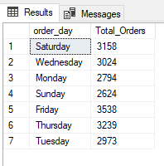

1. Monthly Trend For Total Orders

SELECT DATENAME(MONTH, order_date) as Month_Name, COUNT(DISTINCT order_id) as Total_Orders

from pizza_sales

GROUP BY DATENAME(MONTH, order_date)

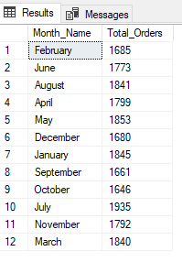

SELECT DATENAME(MONTH, order_date) as Month_Name, COUNT(DISTINCT order_id) as Total_Orders

from pizza_sales

GROUP BY DATENAME(MONTH, order_date)

ORDER BY Total_Orders DESC

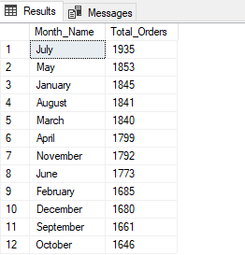

1. Percentage of pizza sales by pizza category with particular month(January)

SELECT pizza_category,SUM(total_price) as Total_Sales, sum(total_price) * 100 / (SELECT SUM(total_price) from pizza_sales WHERE MONTH(order_date) = 1) as PCT

from pizza_sales

WHERE MONTH(order_date) = 1

GROUP BY pizza_category

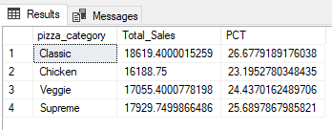

1. Percentage of sales by pizza SIZE

SELECT pizza_size,CAST(SUM(total_price) AS DECIMAL(10,2)) as Total_Sales, CAST(sum(total_price) * 100 /

(SELECT SUM(total_price) from pizza_sales ) AS DECIMAL(10,2)) as PCT

from pizza_sales

GROUP BY pizza_size

ORDER BY PCT DESC

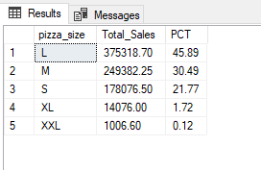

1. Top five pizza by revenue

SELECT TOP 5 pizza_name,SUM(total_price) AS total_revenue FROM pizza_sales

GROUP BY pizza_name

ORDER BY total_revenue DESC

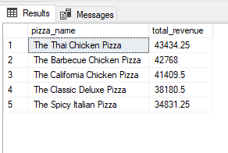

1. Bottom five pizza by revenue

SELECT TOP 5 pizza_name,CAST(SUM(total_price) AS DECIMAL (10,2)) AS total_revenue FROM pizza_sales

GROUP BY pizza_name

ORDER BY total_revenue ASC

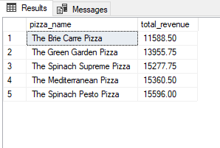

1. Top five pizza by quantity

SELECT TOP 5 pizza_name,CAST(SUM(quantity) AS DECIMAL (10,2)) AS total_quantity FROM pizza_sales

GROUP BY pizza_name

ORDER BY total_quantity DESC

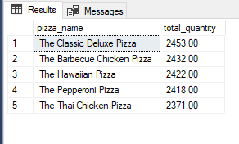

1. Bottom five pizza by quantity

SELECT TOP 5 pizza_name,CAST(SUM(quantity) AS DECIMAL (10,2)) AS total_quantity FROM pizza_sales

GROUP BY pizza_name

ORDER BY total_quantity ASC

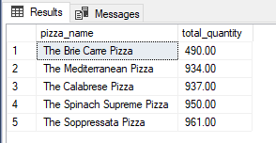

1. Top five pizza by orders

SELECT TOP 5 pizza_name, count(distinct order_id) AS total_orders FROM pizza_sales

GROUP BY pizza_name

ORDER BY total_orders desc

